STANDARD FORMAT OF “LEHENGA DESCRIPTION”


For Online Selling Products
Design Name: TAARANI-C
Product Colours NO.: C3
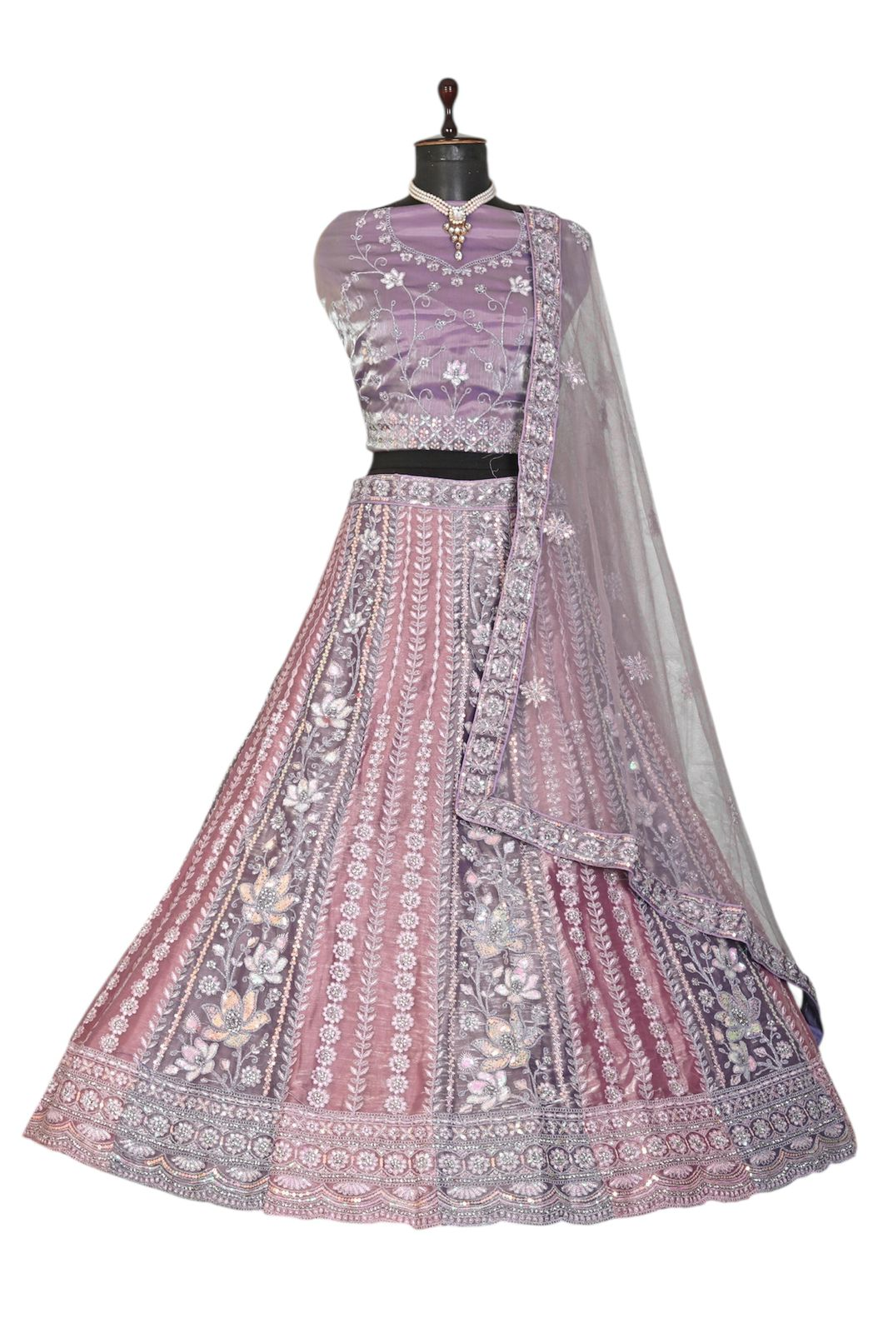
Particulars | Details
Lehenga Fabric | Burberry Silk
Blouse Fabric | Burberry Silk
Dupatta Fabric | Net Silk
Work Type | Heavy Zari & Stone Work
Colour | Purple with Light-Gajari
Pattern | Girlish Designer Lehenga
Stitching Type | Semi-Stitched (Can be customized up to 44")
Occasion | Wedding, Reception, Engagement & Festive Wear
Fit Type | Regular Fit
Care Instructions | Dry Clean Only
Package Contents | 1 Lehenga, 1 Blouse Piece, 1 Dupatta

KEY HIGHLIGHTS
- Crafted using premium Burberry Silk for a rich and luxurious feel
- Matching Burberry Silk blouse included for a coordinated look
- Lightweight Net Silk dupatta adds elegance and comfort
- Enhanced with fine Jari & Stone work for a festive shine
- Semi-stitched lehenga (44” size) offers easy customization
- Available in beautiful festive colours: Pink with Blue, Purple with Light-Gajari (as per stock’s Availability)
- Perfect choice for festive occasions, parties, and celebrations
- Regular-fit design ensures comfort for long hours
- Dry-clean-only fabric to maintain original shine and quality

